**Sierra Meadows Partnership Grant Program**

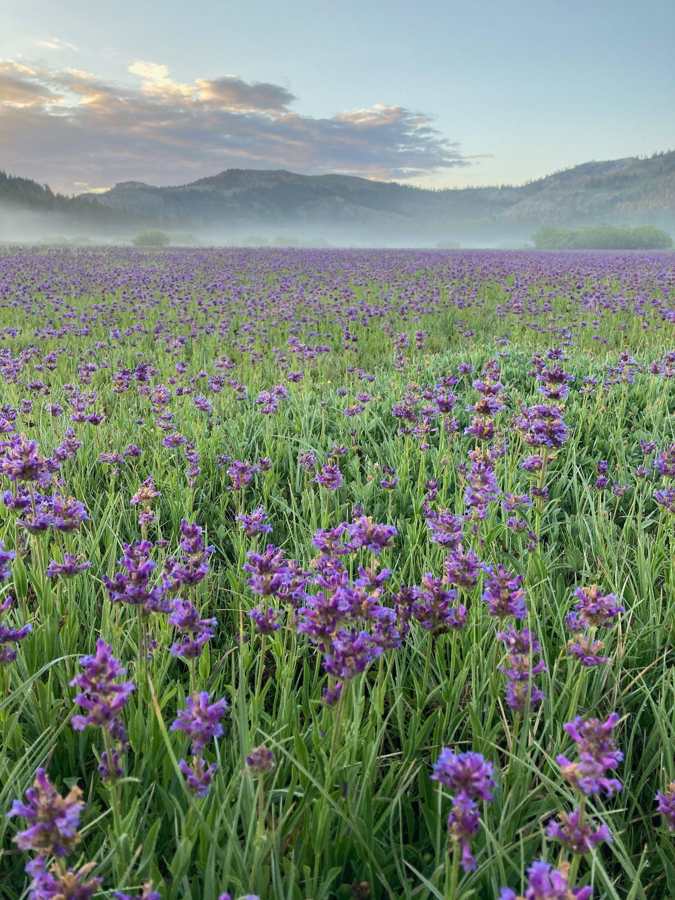

**Proposal Solicitation Notice and Grant**

**Guidelines for Indigenous-led Projects**

August 2024

**Contents**

Introduction

Background

PSN Priorities

Eligibility

Applying Entities

Geographic Scope

Eligible Project Types

Ineligible Projects

Project Term

Application Submission and Selection

Application Process

Administrative Review

Application Evaluation Process

Project Guidelines and Requirements

Application Attachments

Project Funding Requirements

Budget

Cost Share

Indirect Costs

Eligible and Ineligible Costs

Appendix

# Introduction

The Sierra Meadows Partnership is inviting proposals for projects that support restoration of mountain meadows in the Sierra Nevada, Cascade Mountains, and Modoc Plateau. The purpose of this proposal solicitation notice (PSN) and guidelines document is to establish the process, procedures, and general requirements through which the Sierra Meadows Partnership (herein referred to as “SMP” and “the Partnership”) will administer funds for the SMP Grant Program. The funds for the SMP Grant Program were awarded to Point Blue Conservation Science (Point Blue) by the California Wildlife Conservation Board (WCB) via a block grant. The SMP anticipates awarding approximately $20 million in grants selected through this program, resulting in the restoration of 6,000 meadow acres and completed planning on an additional 4,000 acres. $2 million of this funding has been reserved for projects led by Indigenous groups. **As of June 2024, $500,000 of the funding reserved for projects led by Indigenous groups is still available.** The minimum grant amount requested should be no less than $10,000. Questions related to this PSN and SMP Grant Program may also be directed to Point Blue via email ([meadows@pointblue.org](mailto:meadows@pointblue.org)).

# Background

Wet meadows comprise less than 2% of the Sierra Nevada and southern Cascades ecosystem of California yet provide a disproportionately large number of ecological services. They are hotspots for biodiversity, they store and purify water, attenuate flood flows, provide refugia during and after fires, store large concentrations of soil carbon, and are culturally important to many of the Tribes of the Sierra Nevada. Unfortunately, Tribes have been prevented from accessing and managing Sierra meadows and an overwhelming majority of these meadows have been degraded, reducing the ecological and cultural benefits they provide. As the impacts of climate change increase, so do both the importance of these headwater wetlands, and the threats to their ability to function and provide vital services to humans as well as the species that rely upon them.

The SMP was formed in 2016 to address an overwhelming need to restore the vitality and resilience of these ecosystem workhorses and biodiversity hotspots. The Partnership is a broad coalition of public and private organizations working collaboratively to restore and protect 30,000 acres of Sierra meadow by 2030. The vision of the Partnership is a greater Sierra Nevada region with healthy and resilient meadows that provide sustained benefits to fish and wildlife as well as the people of California. The Partnership is governed by a Management Board that is currently chaired by Point Blue Conservation Science.

The SMP recognizes that the meadows of the Sierra Nevada and Southern Cascades have been used by Indigenous people for millennia and continue to provide cultural resources, high-quality recreation, and clean water to local inhabitants and those downstream. However, despite their cultural significance, the meadow restoration community has historically fallen short in incorporating the voices and priorities of Indigenous groups and disadvantaged communities. To help address this, 10% of SMP Grant Program funds have been earmarked for restoration planning, implementation, and/or technical assistance projects led by Indigenous groups including but not limited to Tribes, Tribal consortiums, and Tribal-led NGOs.

# PSN Priorities

The Partnership strives to fund projects that engage with and provide a benefit to California Native American Tribes and underserved or disadvantaged communities throughout the Sierra, Southern Cascades, and Modoc Plateau. Projects must have a nexus with meadows but we seek projects that address the priorities and goals of Indigenous groups as they relate to meadow restoration, meadow restoration training, cultural practices, and outreach and education. The Partnership recognizes the importance of early consultation and collaboration with California Native American Tribes in the development of projects and suggests Tribal groups contact the SMP early in the process of developing a proposal.

# Eligibility

## Applying Entities

Native American Tribes/tribal groups, Indigenous-led nonprofit organizations, tribal consortiums or partnerships, and other tribally-led groups are eligible to submit applications. Entities such as NGOs, local, state, and federal agencies, and private landowners that are not Tribes or Tribal groups may be eligible to submit applications if they have a direct focus on Indigenous priorities and/or are applying on behalf of a Tribal entity. These entities should contact Point Blue via email ([meadows@pointblue.org](mailto:meadows@pointblue.org)) to confirm their eligibility before applying.

## Geographic Scope

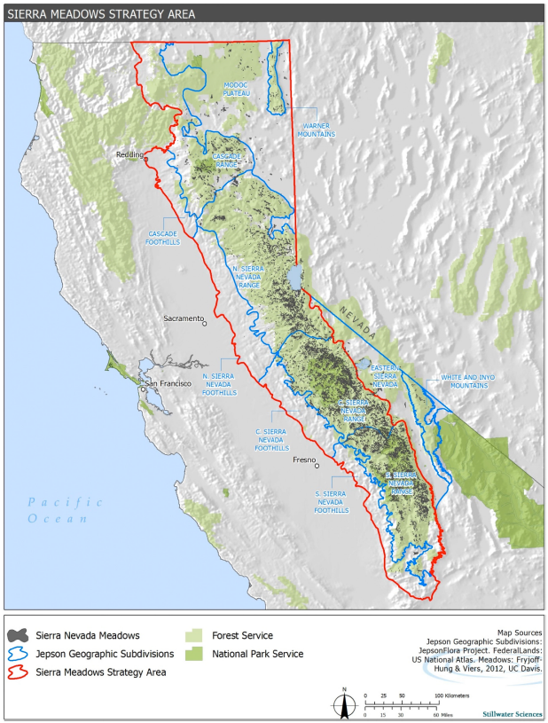Projects must be located within the boundaries of the Sierra Meadows Strategy Area (Figure 1).

Figure 1. Sierra Meadows Strategy Area.

## Eligible Project Types

Implementation (e.g., restoration), planning (e.g., design and environmental review that lead to future implementation), and technical assistance (e.g., training, studies, prioritization, partnership development, stewardship, facilitation of cultural practices) projects are eligible for consideration in response to this PSN. **Planning and implementation activities cannot be combined in one proposal.**

### Planning Projects

Planning grants provide funding for necessary activities that will lead to a specific future on-the-ground implementation project(s) that is likely to qualify for future implementation funding. If the application seeks funding for permitting, a description of the permits needed and a timeline for obtaining them should be included in the application.

### Implementation Projects

Implementation grants shall fund construction of restoration projects. They are intended to support high priority "shovel ready" projects that have advanced to the stage where planning, land tenure, and design plans have been completed. Implementation applications should include design plans appropriate for the complexity of restoration intervention being proposed. Implementation projects may include development of final design plans and permitting as project activities but must be California Environmental Quality Act (CEQA) compliant (project has received a Notice of Determination or Notice of Exemption) before contracts can be finalized. It is required that implementation projects are CEQA compliant before applying.

### Technical Assistance Projects

Grants may be given to enable entities to support the development, management and implementation of projects that advance the practice of meadow restoration and management. Examples of projects eligible for technical assistance include: Scientific studies, or other analyses that advance meadow restoration science; Regional planning and prioritization; Restoration monitoring; Partnership and collaborative development; Outreach and education; Economic development/financing planning; Communication planning.

## Ineligible Projects

Examples of projects that may be ineligible, include but are not limited to:

* Acquisition projects;
* Projects mandated to address a violation of, or an order to comply with, a law or regulation;
* Projects for the purpose of regulatory compliance or mitigation;
* Projects that employ herbicides with grant or matching funds during the duration of the grant period

## Project Term

Projects must be completed with funds expended by December 31, 2026.

# Application Submission and Selection

## Application Process

Prospective applicants are encouraged to contact Point Blue staff via email at [meadows@pointblue.org](mailto:meadows@pointblue.org) to discuss potential project ideas and available application support prior to applying. Point Blue staff and members of the Partnership Management Board are available to work with and advise applicants during the preparation of their application.

Applicants will apply using the [application form](https://docs.google.com/document/d/1XylwdZdr0w_YxyCxKMbJ9PRihP5ZJ0I-/edit?usp=sharing&ouid=101213476792174679360&rtpof=true&sd=true) and [budget worksheet](https://docs.google.com/spreadsheets/d/1xqpYySDI1Xz6xojf3g0TLzgpFugU5-e1PSzod4cl5KU/edit?usp=sharing). A completed application form and budget worksheets A and B must be submitted as attachments via e-mail to [meadows@pointblue.org](mailto:meadows@pointblue.org) with “SMP Grant Program Application” and the Project Title in the subject line. Applications will be accepted continually until all funds have been allocated (Table 1). Applications must be received by Point Blue at least 3 weeks prior to the next SMP Management Board Grant Program Meeting to be considered for funding at that meeting. SMP Management Board Grant Program Meetings in 2024 will be held on the fourth Wednesday in February and May, and on the third Wednesday in November.

Table 1. Milestone dates for the SMP Grant Program for 2024

| **Date** | **Description** |
| --- | --- |
| February 7, 2024 | Last day to submit an application that would be considered at the February SMP Management Board meeting to vote on projects |
| February 28, 2024 | SMP Management Board meeting to vote on projects |
| May 1, 2024 | Last day to submit an application that would be considered at the May SMP Management Board meeting |
| May 22, 2024 | SMP Management Board meets to vote on projects |
| July 3, 2024 | Last day to submit an application that would be considered at the July SMP Management Board meeting |
| July 24, 2024 | SMP Management Board meets to vote on projects |
| October 30, 2024 | Last day to submit an application that would be considered at the November SMP Management Board meeting |
| November 20, 2024 | SMP Management Board meets to vote on projects |

## Administrative Review

Point Blue will conduct an administrative review of all applications to determine if applications were completed as required and the project generally meets the PSN priorities. Administrative review criteria include:

* Project meets eligibility requirements
* Application completed per PSN instructions
* For Implementation Projects, California Environmental Quality Act (CEQA) completed (applicants without CEQA determination are strongly encouraged to reach out to [meadows@pointblue.org](mailto:meadows@pointblue.org) before applying).

Applications not meeting these criteria will be notified by Point Blue within 2 weeks of application submission.

## Application Evaluation Process

All eligible and complete applications will be evaluated and scored by members of the SMP Management Board based on the evaluation criteria provided in the Appendix. Scoring will be anonymous. When scoring is complete, the SMP Management Board will vote on funding based on the:

* Reviewer scores;
* Alignment with PSN priorities and guidelines;
* Distribution of funds among geographies, applicants, etc.;
* Availability of funds;
* Project readiness.

A majority vote approves the project. All votes on applications are anonymous. The Management Board may recommend modifications, including recommending partial funding, in order to meet program priorities, funding targets, and available funding limitations. After voting, Point Blue staff will notify the applicant and work with awardees to prepare a draft Grant Agreement and any other associated materials.

# Project Guidelines and Requirements

## Application Attachments

Applications may include spatial data files (.kml or .shp), representative photos, design documents, maps, and letters of support as attachments to the submission.

## Project Funding Requirements

All grantees must be deemed an eligible grantee and shall be required to enter into a grant agreement with Point Blue Conservation Science, which imposes certain conditions on the grantee and/or the landowner including access to the project area, project delivery, maintenance, monitoring, and long-term stewardship of the project improvements. All implementation projects will require a signed agreement — including both the landowner and project lead — with Point Blue to maintain project improvements for 15 years.

## Budget

The budget should be sufficiently detailed to describe project costs. The budget should be divided into 5 or fewer tasks and justification should be provided for costs to ensure that they are appropriate to the work proposed. Costs should include project management which will include monthly invoice summaries of work completed and a final report. Example tasks for an implementation project include: Project Management, Project Construction, Monitoring & Reporting.

### Cost Share

Cost share is the portion of the project cost not funded by the Grant Program and is provided by the applicant and/or other sources and can be cash or in/kind. *Cost share is not required for Indigenous-led projects.*

### Indirect Costs

Indirect costs are allowed at a rate of up to 20%, regardless of the applicant organization’s approved rate (e.g. Negotiated Indirect Cost Rate), and can be applied to personnel, benefits, supplies, and travel. Indirect costs include but are not limited to: utilities, office space rental, phone service, and other administrative activities. If a grantee seeks to recover indirect costs from an SMP Grant, this item should be included as a line item in the approved project budget.

### Eligible and Ineligible Costs

Costs that are eligible for reimbursement are those that have been clearly indicated in the full application and are necessary for completion of the project. Any other costs can only be reimbursed with advance written permission from Point Blue prior to submission of the invoice that includes the other cost(s).

Costs that are ineligible for reimbursement through an awarded grant include:

* All costs incurred outside of the grant agreement term (i.e., prior to or after the grant term);
* Travel costs that do not adhere to state guidelines;
* Student tuition and/or registration fees;
* Purchase of electronics or other equipment not specifically identified in the grant application, without prior written authorization from Point Blue;
* Food or beverages not associated with travel activities (must not include alcohol);
* Entertainment costs;
* Contributions and donations, including cash, property, and services to others, regardless of the recipient;
* Fines, penalties, damages, and other settlements resulting from violations or noncompliance;
* Costs associated with legal defense funds or endowments; and
* Costs associated with fundraising.

# 

# Appendix

Table A1. Scoring rubric for Indigenous-led projects.

| **Category** | **Criteria** | **Points** | **Weight** | **Max Points** |
| --- | --- | --- | --- | --- |
| Need and Impact | Proposal identifies a clear need and articulates well how it ties to Indigenous goals or priorities. | 5 | 5 | 25 |
| Approach | Project has identified a reasonable approach to address the problem and achieve the intended benefits. | 5 | 5 | 25 |
| Applicability to SMP goals | Project advances SMP meadow non-cultural restoration/conservation goals and strategy | 5 | 3 | 15 |
| Budget | Proposed budget is appropriate to the work proposed and is consistent with the tasks shown in the project narrative. (5 points: Budget is detailed, accurate, and costs appear reasonable; 0 points: Budget lacks sufficient detail, has inaccuracies, and costs do not appear reasonable) | 5 | 2 | 10 |
| Readiness | Project can be completed in the timeline provided and has sufficient resources to accomplish it. For projects requiring them, property access and environmental compliance are demonstrated. | 5 | 2 | 10 |
|  |  |  |  | **85** |