**Sierra Meadows Partnership Grant Program**

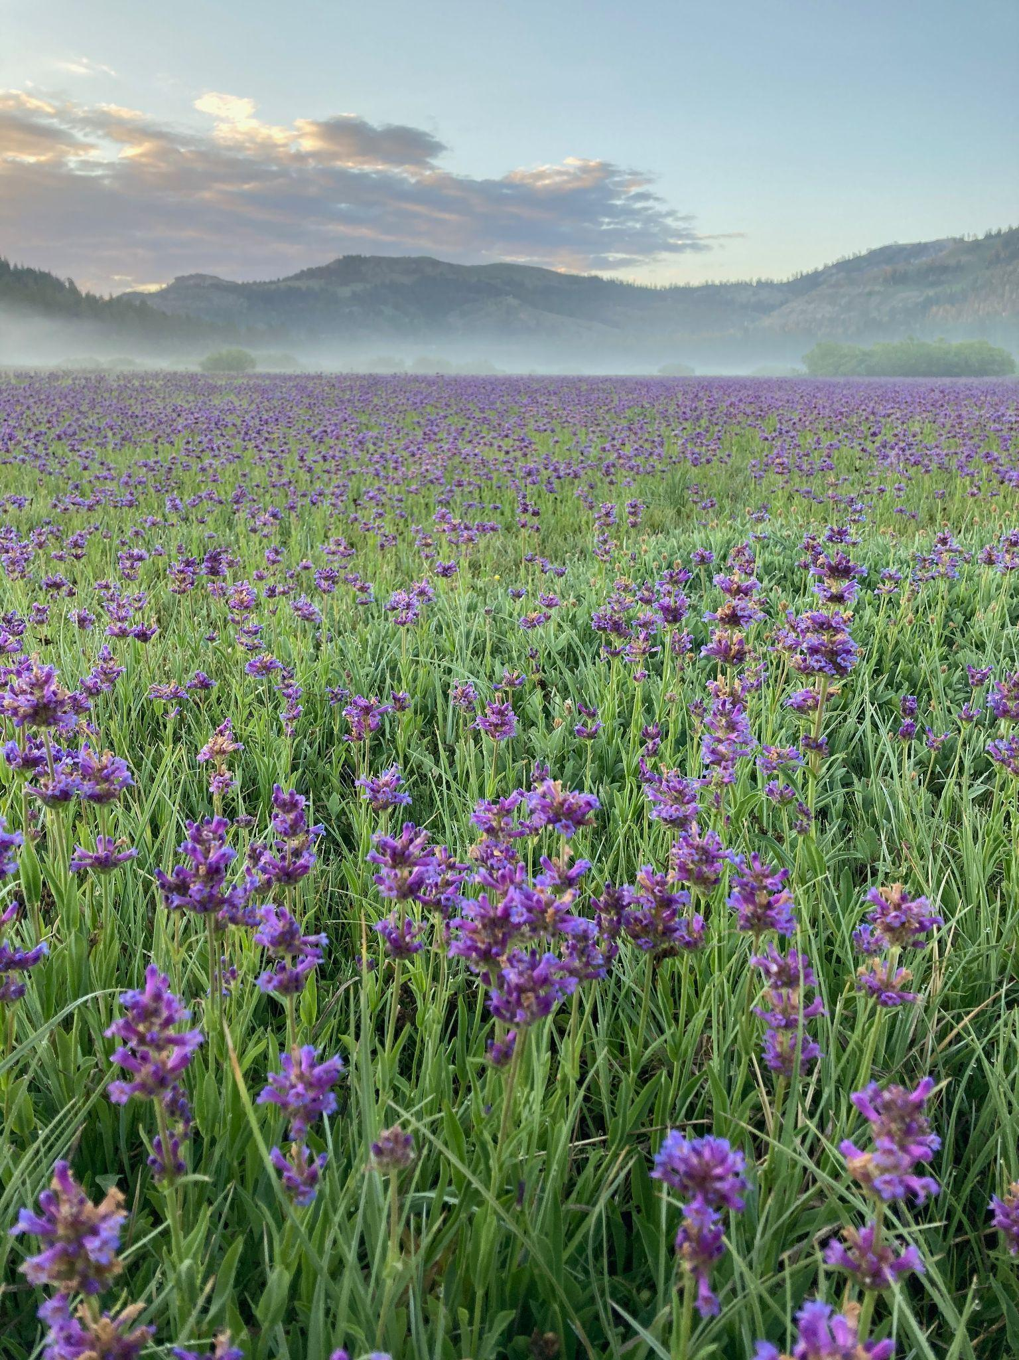

**Proposal Solicitation Notice**

**and Grant Guidelines**

August 2024

**Contents**

Introduction

Background

PSN Priorities

Eligibility

Applying Entities

Geographic Scope

Project Types

Planning Projects (up to $350,000 available)

Implementation Projects (up to $4 M available)

Indigenous Led Projects ($500,000 available)

Ineligible Projects

Project Term

Application Submission and Selection

Application Process

Administrative Review

Application Evaluation Process

Application Selection

Project Guidelines and Requirements

Justification

Benefits

Climate Resilience

Project Monitoring

Application Attachments

Project Funding Requirements

Budget

Cost Share

Indirect Costs

Eligible and Ineligible Costs

Appendix

# Introduction

The Sierra Meadows Partnership is inviting proposals for projects that restore mountain meadows in the Sierra Nevada, Cascade Mountains, and Modoc Plateau. The purpose of this proposal solicitation notice (PSN) and guidelines document is to establish the process, procedures, and general requirements through which the Sierra Meadows Partnership (herein referred to as “SMP” and “the Partnership”) will administer funds for the SMP Grant Program. The funds for the SMP Grant Program were awarded to Point Blue Conservation Science (Point Blue) by the California Wildlife Conservation Board (WCB) via a block grant. The SMP anticipates awarding approximately $20 million in grants selected through this program, resulting in the restoration of 6,000 meadow acres and completed planning on an additional 4,000 acres. The minimum grant amount requested should be no less than $10,000. Questions related to this PSN and SMP Grant Program may also be directed to Point Blue via email ([meadows@pointblue.org](mailto:meadows@pointblue.org)).

# Background

Wet meadows comprise less than 2% of the Sierra Nevada and southern Cascades ecosystem of California yet provide a disproportionately large number of ecological services. They are hotspots for biodiversity, they store and purify water, attenuate flood flows, provide refugia during and after fires, and store large concentrations of soil carbon. Meadows and their riparian areas are also extremely important habitats for wildlife. Unfortunately, an overwhelming majority of Sierra meadows have been degraded, reducing the ecological benefits they provide. As the impacts of climate change increase, so do both the importance of these headwater wetlands, and the threats to their ability to function and provide vital services to humans as well as native species.

The SMP was formed in 2016 to address an overwhelming need to restore the vitality and resilience of these ecosystem workhorses and biodiversity hotspots. The Partnership is a broad coalition of public and private organizations working collaboratively to restore and protect 30,000 acres of Sierra meadow by 2030. The Partnership was formed with the mission to foster expansion of and more effective collaboration among partners currently engaged in meadow conservation to increase the pace, scale and efficacy of meadow restoration and protection in the Sierra for the benefit of people and ecosystems. The vision of the Partnership is a greater Sierra Nevada region with healthy and resilient meadows that provide sustained benefits to fish and wildlife as well as the people of California. The Partnership is governed by a Management Board that is currently chaired by Point Blue Conservation Science.

# PSN Priorities

Projects must focus on the restoration of meadow habitat or advance the practice of meadow restoration and management through strategic monitoring, research, coordination, and/or communications. We seek projects that will restore ecological processes that confer increased resilience to meadow systems and improved ecological services for native species as well as humans. We will fund projects that demonstrate multiple benefits, including (but not limited to) wildlife habitat, hydrologic functioning, fire refugia, carbon sequestration, and public access. In addition, projects need to be based on up-to-date meadow restoration science and practices. These priorities are closely aligned with the Partnership’s strategic plan: the [Sierra Meadows Strategy](https://caltrout.org/book/sierra-meadows-strategy/mobile/index.html#p=1).

The Partnership also strives to support projects with long-term durability, to fund projects that engage with and provide a benefit to California Native American Tribes and underserved or disadvantaged communities, and to fund projects throughout the Sierra, Southern Cascades, and Modoc Plateau. The Partnership recognizes the importance of early consultation and collaboration with California Native American tribes in the development of projects.

# Eligibility

## Applying Entities

Native American Tribes/Tribal groups, nonprofit organizations, local, state, and federal agencies, and private landowners, among others, are eligible to submit applications. The organizations that comprise the SMP Management Board may apply but must recuse themselves from the application evaluation and selection process for applications for which they are the lead entity.

## Geographic Scope

Projects must be located within the boundaries of the Sierra Meadows Strategy geography 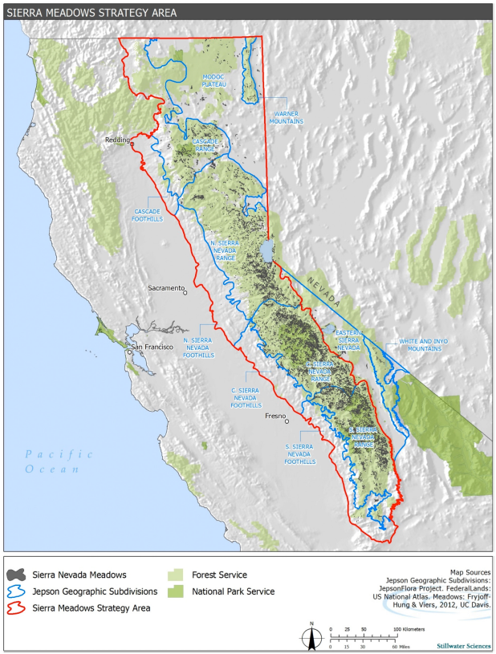(Figure 1).

Figure 1. Sierra Meadows Strategy area.

## Project Types

Implementation (e.g., restoration) and planning (e.g., design and environmental review that lead to future implementation) projects are eligible for consideration in response to this PSN. Proposals should not mix project types but may apply for multiple “projects” within a type (e.g. planning of 3 meadows). Total funds per project type available is updated following each round of grant making.

### *Planning Projects* (up to $350,000 available)

Planning grants provide funding for necessary activities that will lead to a specific future on-the-ground implementation project(s) that is likely to qualify for future implementation funding. If the application seeks funding for permitting, a description of the permits needed and a timeline for obtaining them should be included in the application.

### Implementation Projects (up to $4 M available)

Implementation grants shall fund construction of restoration projects. They are intended to support high priority "shovel ready" projects that have advanced to the stage where planning, land tenure, and design plans have been completed. Implementation applications should include design plans appropriate for the complexity of restoration intervention being proposed. Implementation projects may include development of final design plans and permitting as project activities but must be California Environmental Quality Act (CEQA) compliant (project has received a Notice of Determination or Notice of Exemption) before contracts can be finalized. It is required that implementation projects are CEQA compliant before applying.

## Indigenous Led Projects *($500,000 available)*

Funds have been earmarked for planning, implementation, and technical assistance projects led by Indigenous groups including but not limited to tribes, tribal consortiums, and tribal led NGOs. Please see the Tribal PSN on the [SMP website](https://www.sierrameadows.org/) to learn more about applying for these funds.

## Ineligible Projects

Examples of projects that may be ineligible, include but are not limited to:

* Acquisition projects;
* Projects mandated to address a violation of, or an order to comply with, a law or regulation;
* Projects for the purpose of regulatory compliance or mitigation;
* Projects that employ herbicides with grant or matching funds during the duration of the grant period

## Project Term

Projects must be completed with funds expended by December 31, 2026.

# Application Submission and Selection

## Application Process

Applicants will apply using the [application form](https://docs.google.com/document/u/0/d/1Cw-jjvOmRxcta14Ek4MjeFQ9JQJbeXVNynKva1i8rno/edit) and [budget worksheet](https://docs.google.com/spreadsheets/d/1xqpYySDI1Xz6xojf3g0TLzgpFugU5-e1PSzod4cl5KU/edit?usp=sharing). A completed application form and budget worksheets A and B must be submitted as attachments via e-mail to [meadows@pointblue.org](mailto:meadows@pointblue.org) with “SMP Grant Program Application” and the Project Title in the subject line. Applications will be accepted continually until all funds have been allocated (Table 1). Applications must be received by Point Blue at least 3 weeks prior to the next SMP Management Board Grant Program Meeting to be considered for funding at that meeting. SMP Management Board Grant Program Meetings in 2024 will be held on the fourth Wednesday in February, May, and July, and on the third Wednesday in November.

Table 1. Milestone dates for the SMP Grant Program for 2024

| **Date** | **Description** |
| --- | --- |
| February 7, 2024 | Last day to submit an application that would be considered at the February SMP Management Board meeting to vote on projects |
| February 28, 2024 | SMP Management Board meeting to vote on projects |
| May 1, 2024 | Last day to submit an application that would be considered at the May SMP Management Board meeting |
| May 22, 2024 | SMP Management Board meets to vote on projects |
| July 3, 2024 | Last day to submit an application that would be considered at the July SMP Management Board meeting |
| July 24, 2024 | SMP Management Board meets to vote on projects |
| October 30, 2024 | Last day to submit an application that would be considered at the November SMP Management Board meeting |
| November 20, 2024 | SMP Management Board meets to vote on projects |

Applications will go through an administrative review for eligibility; eligible applications will be scored by the SMP Management Board based on standardized criteria; then a funding decision will be made by majority vote of the Management Board. The Partnership Management Board may request applicants to revise and resubmit applications, as necessary. Members of the Partnership Management Board are available to work with and advise applicants during the preparation of their application.

It is strongly recommended that prospective applicants contact Point Blue staff via email at [meadows@pointblue.org](mailto:meadows@pointblue.org) for a consultation prior to applying.

## Administrative Review

Point Blue will conduct an administrative review of all applications to determine if applications were completed as required and the project generally meets the PSN priorities. Administrative review criteria include:

* Project meets eligibility requirements
* Application completed per PSN instructions
* For Implementation Projects, California Environmental Quality Act (CEQA) completed (applicants without CEQA determination are strongly encouraged to reach out to [meadows@pointblue.org](mailto:meadows@pointblue.org) before applying).

Applications not meeting these criteria will be notified by Point Blue within 2 weeks of application submission.

## Application Evaluation Process

All eligible and complete applications will be evaluated and scored by members of the SMP Management Board based on the evaluation criteria provided in the Appendix. Scoring will be anonymous. For planning and implementation projects, we will reference the Multiple Benefits score from the [Sierra Meadow Prioritization Tool](https://databasin.org/galleries/e19c0e7c12924434a36b19422b15856b/).

## Application Selection

When scoring is complete, the SMP Management Board will vote on funding based on the:

* Reviewer scores;
* Alignment with PSN priorities and guidelines;
* Distribution of funds among geographies, applicants, etc.;
* Availability of funds;
* Project readiness.

A majority vote approves the project. All votes on applications are anonymous. The Management Board may recommend modifications, including recommending partial funding, in order to meet program priorities, funding targets, and available funding limitations. After voting, Point Blue staff will notify the applicant and work with awardees to prepare a draft Grant Agreement and any other associated materials. Please note that because the amount of funding available is diminishing quickly with each round of project selection, Point Blue and the SMP Management Board may work with approved project proponents to negotiate the final award amount.

# Project Guidelines and Requirements

## Justification

Each application submitted must provide justification for how it addresses the PSN priorities. Each application submitted must include an evaluation of how the proposed activities will result in long-term enduring benefits. Planning and Implementation projects should discuss how they cost effectively deliver acres toward the acreage targets for the Grant Program outlined above.

## Benefits

A goal of this funding is to achieve multiple ecosystem benefits. Each application should include a clear description of expected benefits that will result from project implementation and an approach to measure and report those benefits. Benefits include such things as improved water quality, increased late season flows, improved fish/wildlife habitat, flood attenuation, groundwater storage, creation of pollinator habitat, soil improvement, carbon sequestration, recreational opportunities, community engagement and education, and cultural enhancements. Be specific about how your particular meadow project will provide these benefits and why your meadow is exemplary of these benefits.

## Climate Resilience

Planning projects must include a process to incorporate climate resilience into the design. Implementation projects must explain how project benefits are resilient to climate change driven stressors such as warmer temperatures and more extreme disturbance regimes. Implementation projects that incorporate elements specifically designed for climate change resilience will score higher. Be specific about how your project is incorporating elements that increase its resilience to climate change. See Point Blue’s [Guide to Climate-Smart Meadow Restoration](https://www.pointblue.org/science_blog/a-guide-to-climate-smart-meadow-restoration/) for more information.

## Project Monitoring

Applications shall describe plans for how the project will be monitored and how success will be determined. The scope of the monitoring plan will vary depending on the nature of the project. **All implementation and planning projects must include elements of the** [**Sierra Meadows Wetland and Riparian Area Monitoring Plan**](https://www.sierrameadows.org/wramp)**.** Projects lacking WRAMP monitoring will not be considered for funding. Applicants can work with a representative of the SMP Management Board to adjust the monitoring plan, if necessary, to ensure the proposed parameters are adequate to meet reporting requirements and to assist with consistency of nomenclature, units, and measurements. Monitoring plans should match the scope, size, and scale of the project.

## Application Attachments

Applications for Implementation and Planning projects must include a spatial data file (.kml or .shp) for the project meadow boundary as an attachment to the submission. Other relevant attachments that are encouraged include representative photos, design documents, maps, and letters of support.

## Project Funding Requirements

All grantees must be deemed an eligible grantee and shall be required to enter into a grant agreement with Point Blue Conservation Science, which imposes certain conditions on the grantee and/or the landowner including access to the project area, project delivery, maintenance, monitoring, and long-term stewardship of the project improvements. All implementation projects will require a signed agreement — including both the landowner and project lead — with Point Blue to maintain project improvements for 15 years.

## Budget

The budget should be sufficiently detailed to describe project costs. The budget should be divided into 5 or fewer tasks and consistent with the work plan tasks. Justification must be provided for costs to ensure that they are cost effective and appropriate to the work proposed. Costs should include project management which will include monthly invoice summaries of work completed and a final report. Example tasks for an implementation project include: Project Management, Project Construction, Monitoring & Reporting.

### Cost Share

Cost share is the portion of the project cost not funded by the Grant Program and is provided by the applicant and/or other sources and can be cash or in/kind. Cost share is not required but applications with secured cost share that demonstrates contributions towards total project cost will score more points through the “Cost Share” application evaluation criterion. Cost share should be funds that will be used to directly achieve the project objectives and will be spent during the project timeline.

### Indirect Costs

Indirect costs are allowed at a rate of up to 20%, regardless of the applicant organization’s approved rate (e.g. Negotiated Indirect Cost Rate), and can be applied to personnel, benefits, supplies, and travel. Indirect cannot be applied to subcontracted funds. Indirect costs include but are not limited to: utilities, office space rental, phone service, and other administrative activities. If a grantee seeks to recover indirect costs from an SMP Grant, this item should be included as a line item in the approved project budget.

### Eligible and Ineligible Costs

Costs that are eligible for reimbursement are those that have been clearly indicated in the full application and are necessary for completion of the project. Any other costs can only be reimbursed with advance written permission from Point Blue prior to submission of the invoice that includes the other cost(s).

Costs that are ineligible for reimbursement through an awarded grant include:

* All costs incurred outside of the grant agreement term (i.e., prior to or after the grant term);
* Travel costs that do not adhere to state guidelines;
* Student tuition and/or registration fees;
* Purchase of electronics or other equipment not specifically identified in the grant application, without prior written authorization from Point Blue;
* Food or beverages not associated with travel activities (must not include alcohol);
* Entertainment costs;
* Contributions and donations, including cash, property, and services to others, regardless of the recipient;
* Fines, penalties, damages, and other settlements resulting from violations or noncompliance;
* Costs associated with legal defense funds or endowments; and
* Costs associated with fundraising.

# 

# Appendix

Table A1. Scoring rubric for planning and implementation projects.

| **Category** | **Criteria** | **Points** | **Weight** | **Max Points** |
| --- | --- | --- | --- | --- |
| Need, Impact, and Applicability to SMP Goals | Project clearly articulates the restoration need, has identified multiple ecological benefits that will be achieved, the magnitude of benefits is high, and proposed actions are likely to achieve these multiple benefits. | 5 | 4 | 20 |
| Cost Effective | The magnitude of the benefits is commensurate with the cost. Average cost per acre is expected to be around $2500 for implementation and around $1300 for planning. | 5 | 4 | 20 |
| Durability of Investment | Project delivers enduring benefits and explicitly and specifically addresses climate change resilience benefits to wildlife, habitat, and ecosystem function. Project has compatible land management strategies to meet long-term objectives. Project addresses key stressors/source problems. | 5 | 3 | 15 |
| Monitoring and Reporting | Proposal demonstrates a clear and reasonable approach to monitoring, assessing, and reporting the effectiveness of the project including incorporating SM-WRAMP protocols. | 5 | 3 | 15 |
| Readiness | Proposal demonstrates that access to the property, environmental compliance, permitting, planning, design, engineering review, or other necessary preparations for the project as a whole are sufficient for prompt project completion. | 5 | 2 | 10 |
| Budget | Proposed budget is appropriate to the work proposed and is consistent with the tasks shown in the project narrative. (5 points: Budget is detailed, accurate, and costs appear reasonable; 0 points: Budget lacks sufficient detail, has inaccuracies, and costs do not appear reasonable) | 5 | 2 | 10 |
| Diversity, Equity, Inclusion, and Justice | Project explicitly addresses Diversity, Equity, Inclusion, and Justice considerations, in particular meaningfully engages with and/or is supported by Indigenous groups | 5 | 2 | 10 |
| Community Support and Collaboration | Project has broad-based public and institutional support at the local, regional, or larger scale and the local community or other stakeholders are engaged in project delivery. | 5 | 1 | 5 |
| Economically Disadvantaged Communities | Project is located in and benefits a California designated Severely Disadvantaged Community (SDAC; up to 5 points) or Disadvantaged Community (DAC; up to 3 points) in the CA DWR DAC Mapping Tool (https://gis.water.ca.gov/app/dacs/) according to the layer titled "Disadvantaged Communities - Census Tracts (ACS: 2016-2020)". A direct benefit includes training and workforce education, job opportunities, cultural, recreational, and educational opportunities. | 5 | 1 | 5 |
| Tribal Benefits | Project is on tribal land or otherwise directly benefits Indigenous communities. Benefits include training and workforce education, job opportunities, cultural and educational opportunities. | 5 | 1 | 5 |
| Cost Share | Project provides secured federal, state, private, or local cost share. (5 points: Non-WCB cost share of >40%; 4 points: Non-SMP/WCB cost share of 31-40%; 3 points: Non-WCB cost share of 21-30% will receive 3 points; 2 points: Non-WCB cost share of 11-20%; 1 point: Non-WCB cost share of 1-10%; 0 points: No non-WCB cost share.) | 5 | 1 | 5 |
|  |  |  |  | 120 |